Test Case 1: Register For Site

Successful Registration
- From the landing page click the “Register” button in the upper right.
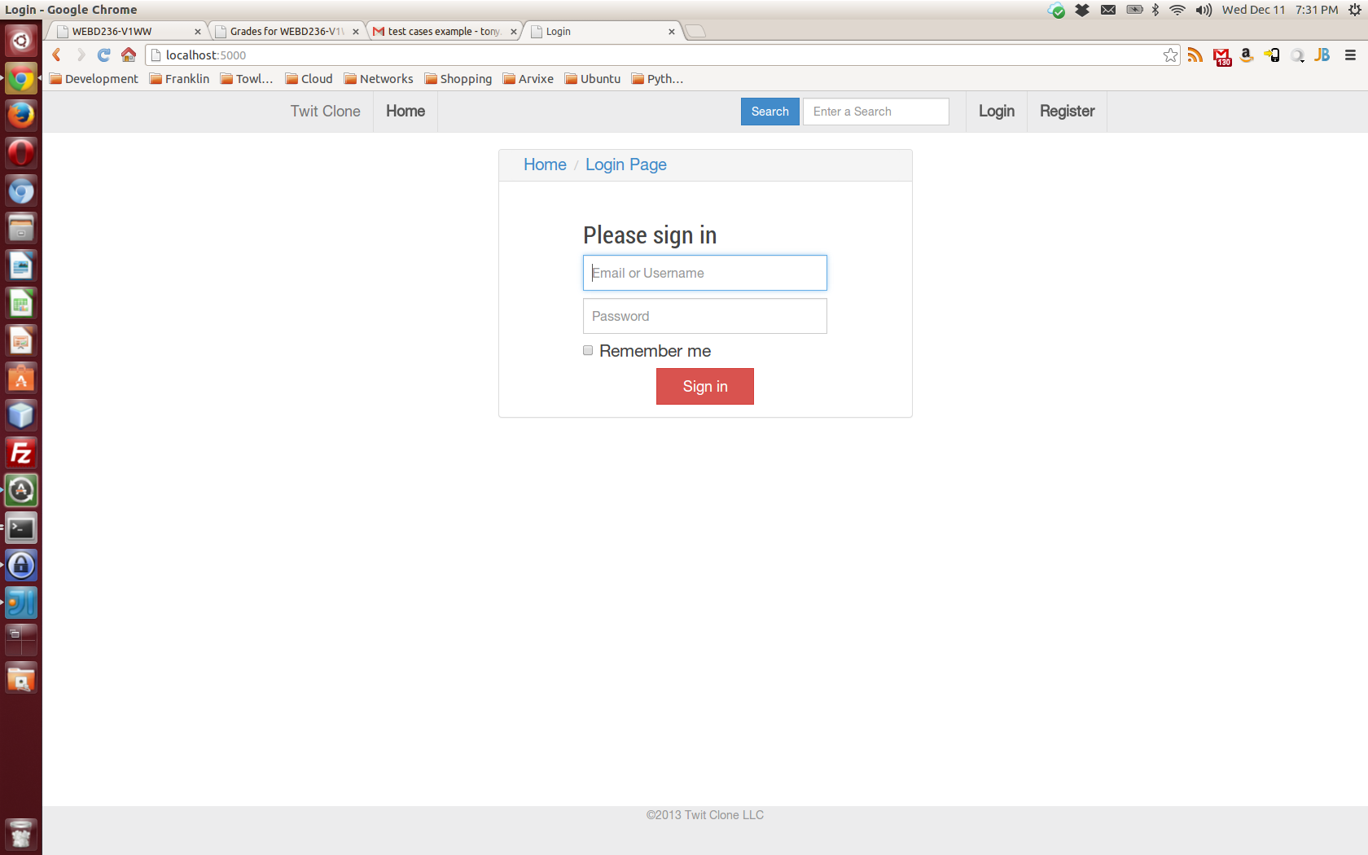
- Fill in all form fields then click the submit button.
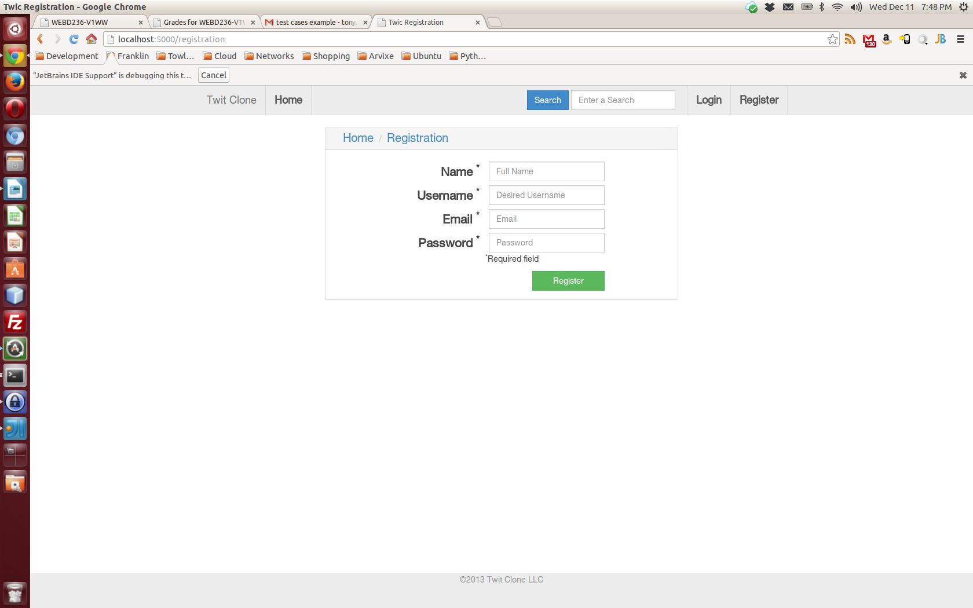
- The newly created user is redirected to the dashboard.
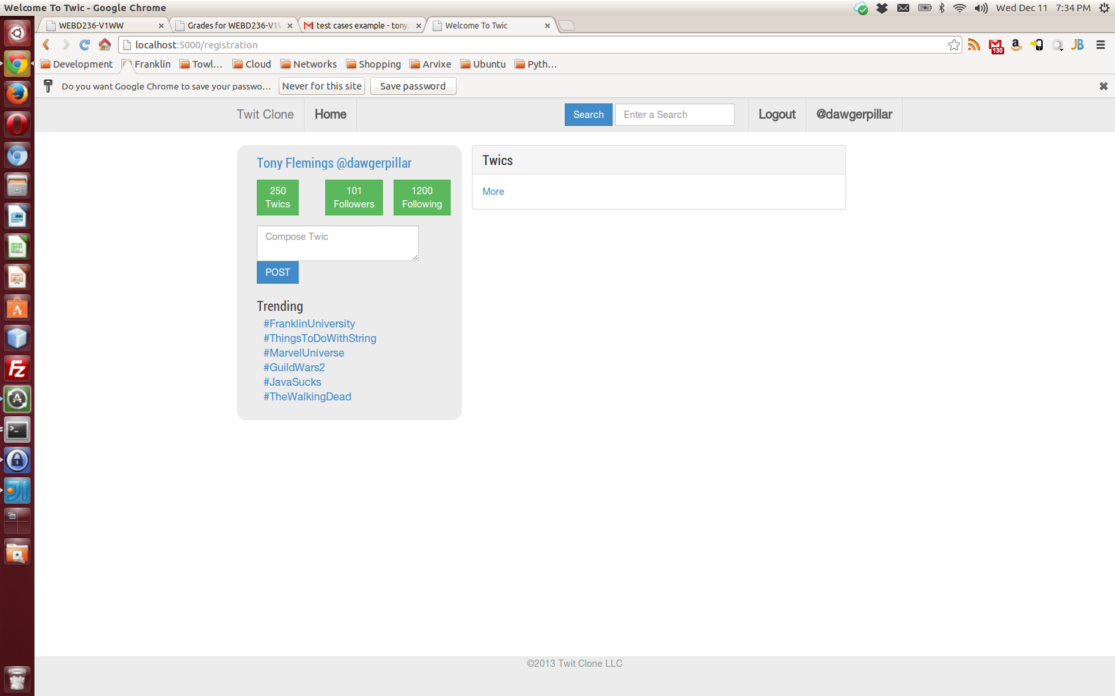

Unsuccessful Registration
If the user does not enter data in all of the form fields the user is presented a message for the first empty field. If the user submits a user name or email address that already exists the user is presented a message stating that the user name already exists.

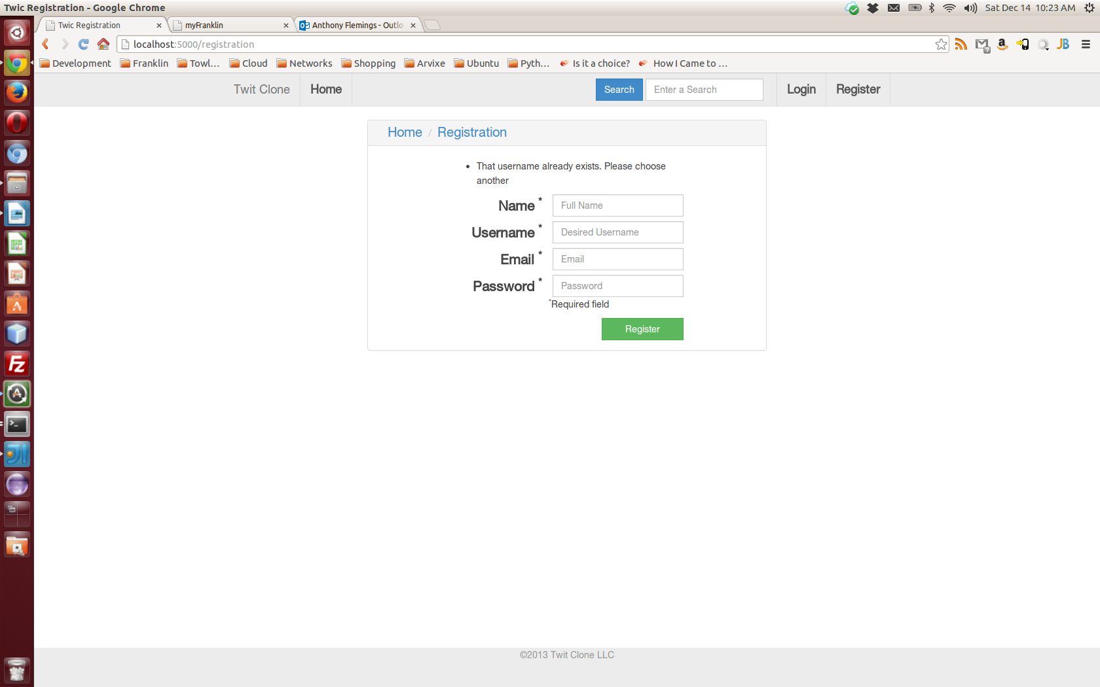

Test Case 2: Login

Successful Login
- The default landing page is the login page.
- The user enters valid credentials and clicks the “Sign in” button and is redirected to the user dashboard.
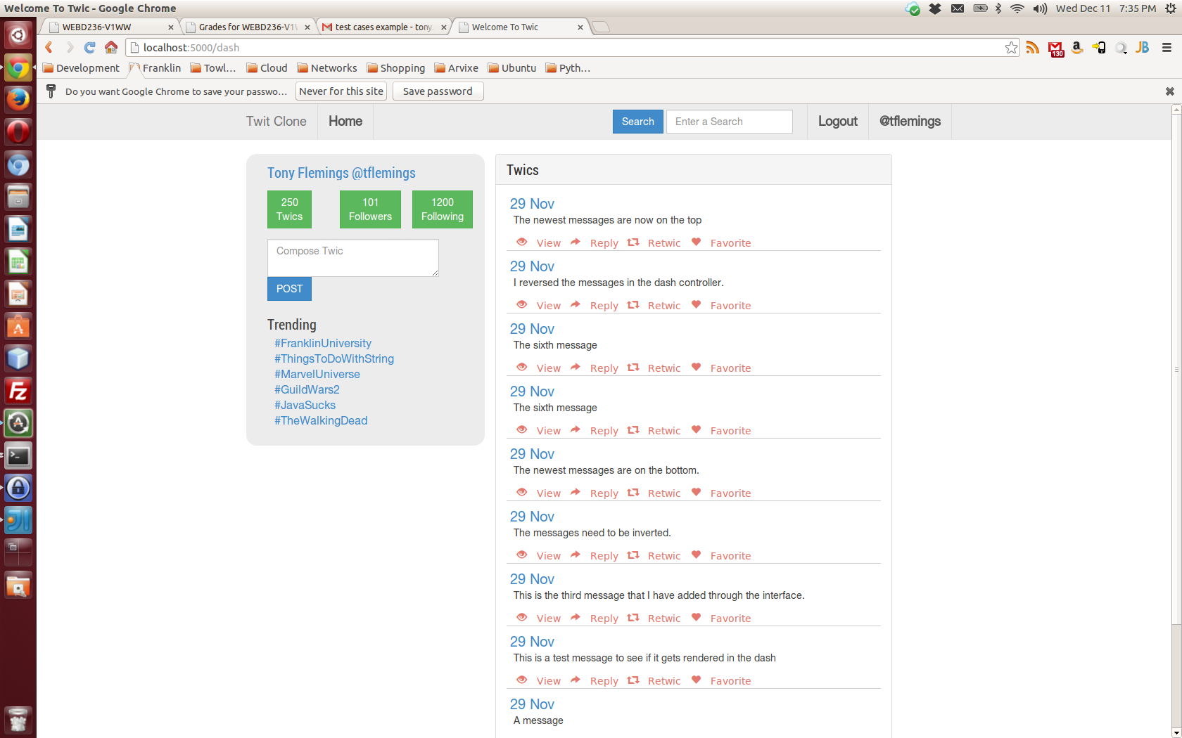
- The “Login” and “Register” buttons are replaced by a “Logout” and user name button.

Unsuccessful Login
If a user submits invalid credentials then the login form is cleared but no message is presented.

Test Case 3: Post A Twic

Successful Post
- From the user dashboard the user can enter text into the “Compose Twic” text box.
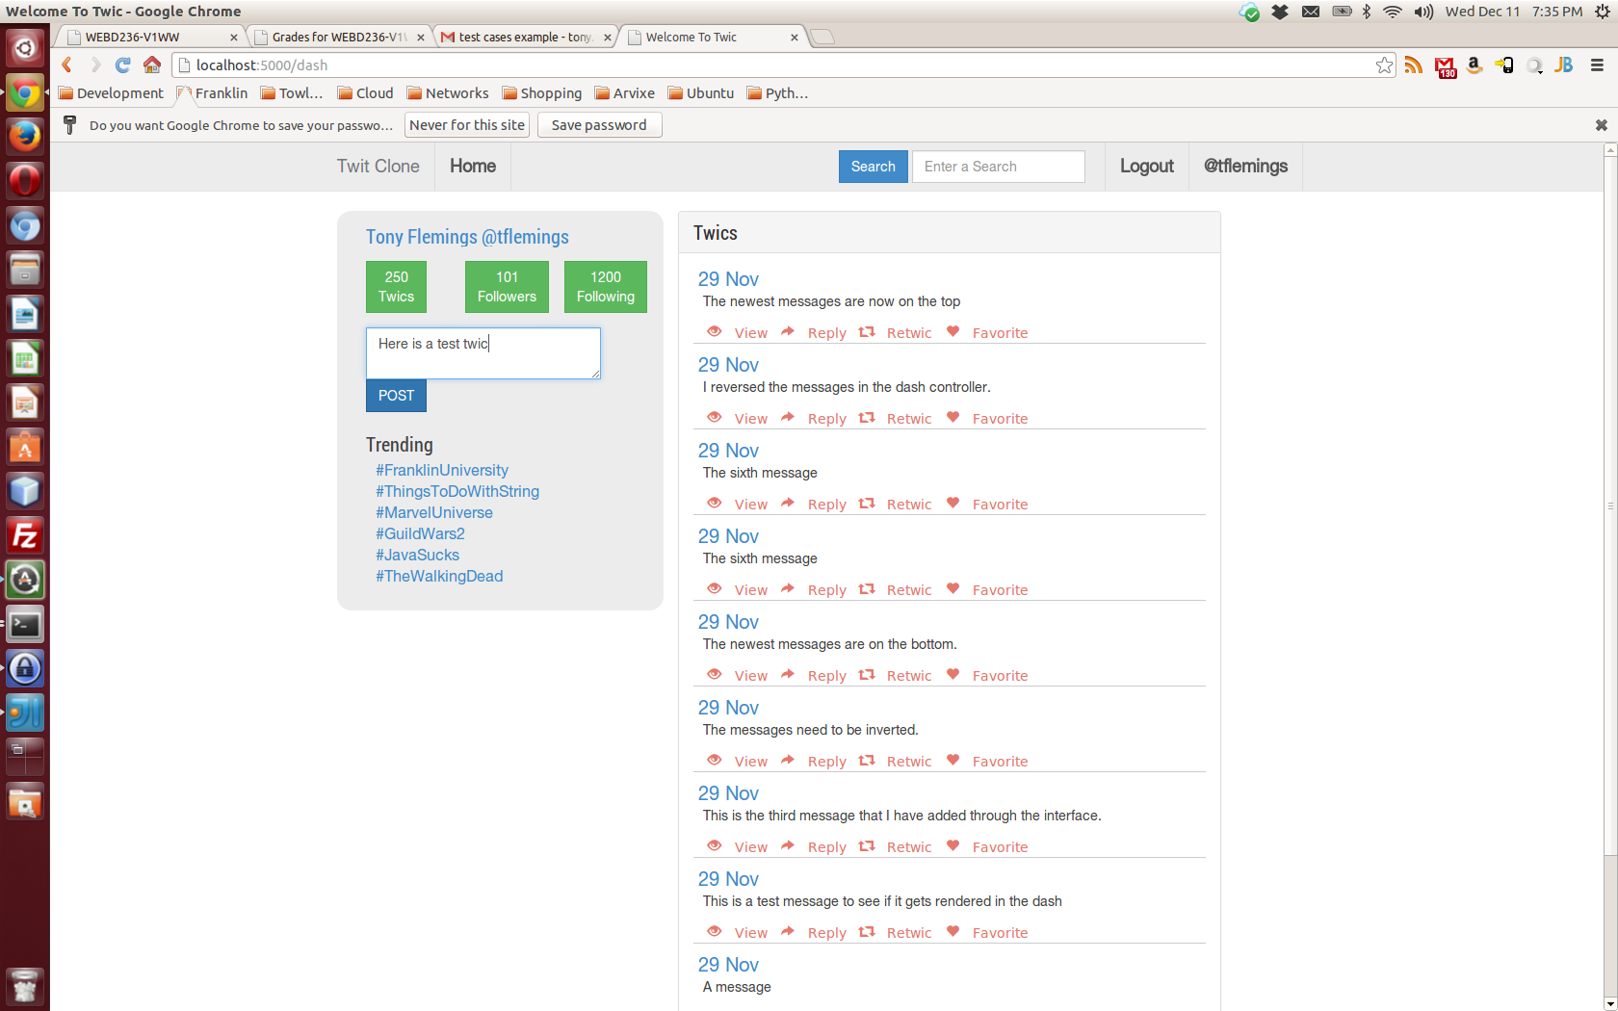
- When the “POST” button is clicked the message is added to the database and immediately is displayed in the user's list of recent Twics.
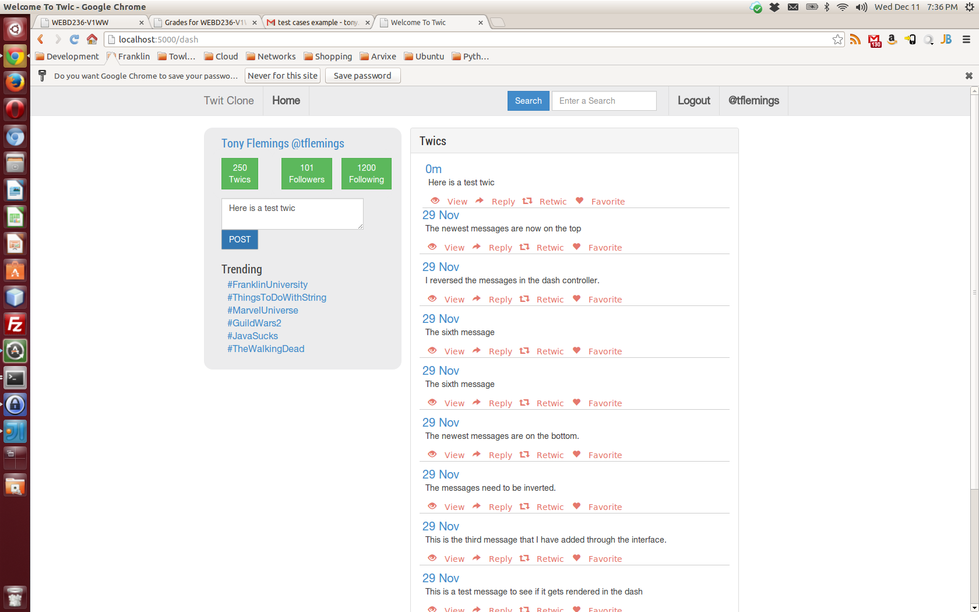

Test Case 4: Logout
- When the “Logout” button is clicked the session is destroyed and the user forwarded to the login page.

Unimplemented Features
- The count of messages, followers, and following members is not dynamic or accurate.
- Trending topics are not dynamic or accurate.
- The View, Reply, Retwic, and Favorite links in the message list do not work.
- The links to view the logged in user's details do not work.
- The search mechanism does not work.
- The message list does not render the Twic handles, links, and hashtags correctly.

